MySQL UPDATE & DELETE

1. UPDATE `pasien` SET `nama_pasien`='Dimas' WHERE `id` = '2'

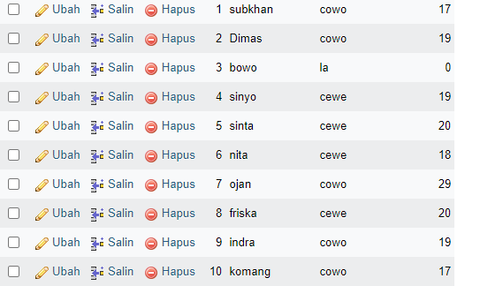

1. UPDATE `pasien` SET `nama_pasien`='INDIRA' WHERE `id` = '6'

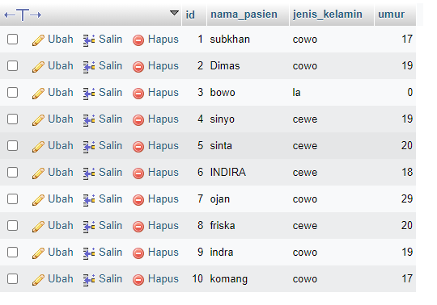

1. UPDATE `pasien` SET `nama_pasien`='LINA' WHERE `id` = '8'

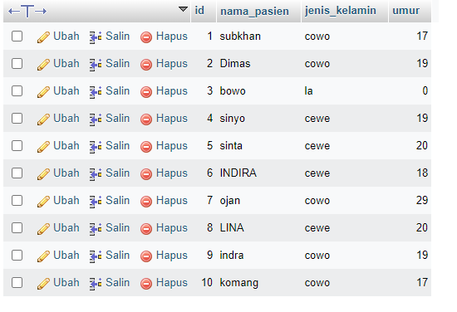

1. [DELETE](http://localhost/phpmyadmin/url.php?url=https://dev.mysql.com/doc/refman/8.0/en/delete.html) FROM `pasien` WHERE id = '11';

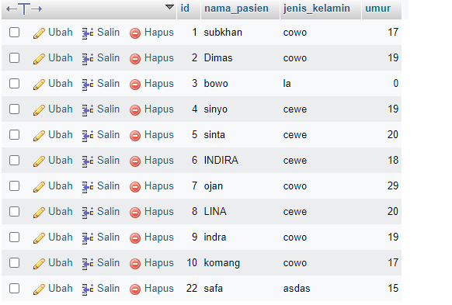

1. DELETE FROM `pasien` WHERE id = '22';

